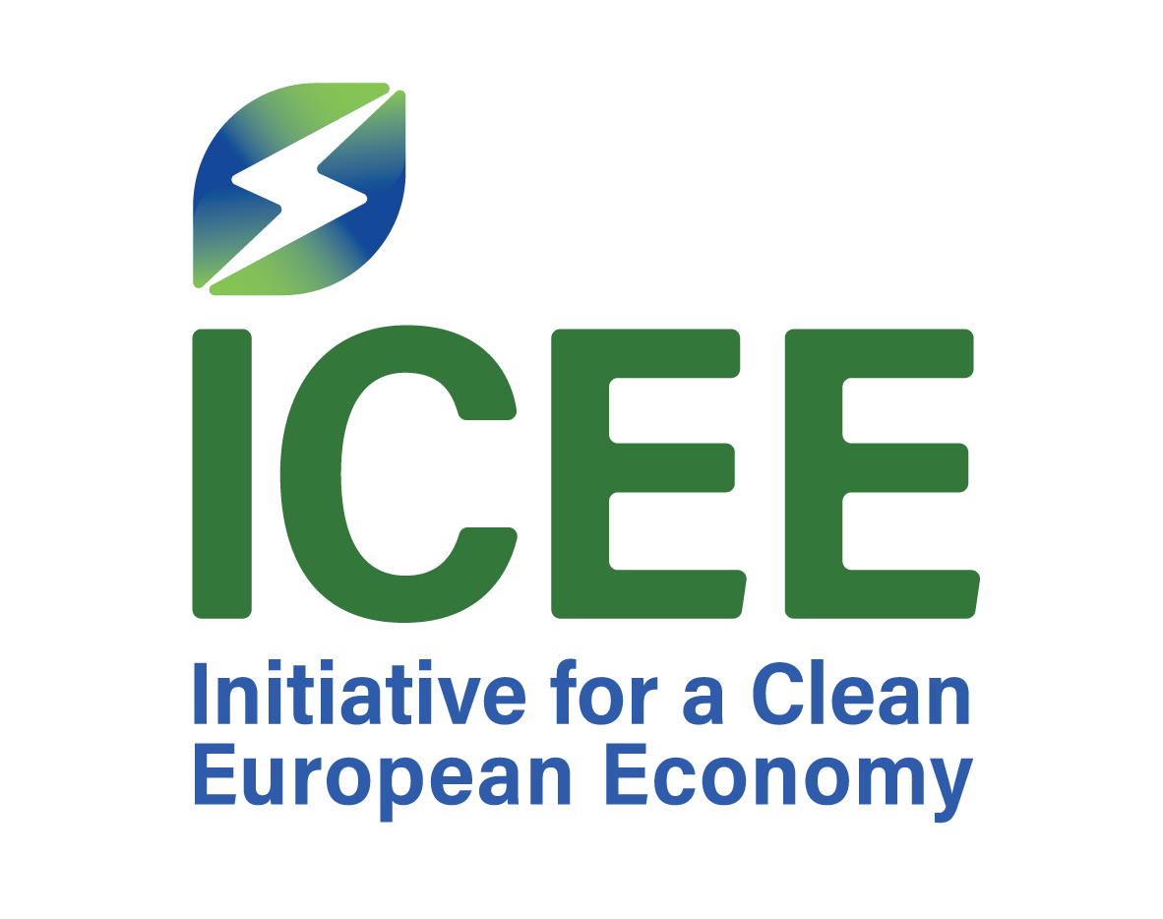

EUROPEAN GREEN TRANSITION FINANCE FORUM – ZAGREB 2026

13 November 2026 | Hotel Esplanade Zagreb | Invitation-only Forum

PROGRAMME

15:30 – 16:00
Arrival, Registration and Welcome Refreshments
Arrival of participants and informal networking prior to the opening of the Forum.

16:00 – 17:00
Research Session I – Financing Europe’s Green Transition
Presentation of ICEE-commissioned research by Prof. Danijel Mlinarić, followed by an exchange with his invited commentator/contributor. The session will address the financing requirements associated with the green transition, investment needs and gaps, and the broader implications for economic policy, competitiveness and implementation across European economies.
• Format: approximately 45 minutes for presentation and discussion with the commentator/contributor, followed by 15 minutes of wider discussion and questions from Forum participants.

17:00 – 18:00
Research Session II – European Automotive Value Chains, Industrial Exposure and Competitiveness
Presentation of ICEE-commissioned research by Prof. Gregor Semieniuk, followed by an exchange with his invited commentator/contributor. The session will examine the transformation of European automotive value chains, industrial investment and exposure, and the implications of the green transition for European competitiveness, resilience and strategic autonomy.
• Format: approximately 45 minutes for presentation and discussion with the commentator/contributor, followed by 15 minutes of wider discussion and questions from Forum participants.
Both research sessions form part of one integrated moderated panel bringing together the two research presenters and their respective commentators/contributors.

18:00 – 19:00
Networking and Pre-Dinner Reception
Informal exchange among Forum participants following the research and policy discussion.

19:00 onwards
Private Dinner
Private dinner for invited Forum participants. The dinner programme will include an address by Prof. Boris Vujčić, Vice-President of the European Central Bank, followed by dinner and informal discussion.

Forum Format
The European Green Transition Finance Forum is conceived as a closed, invitation-only gathering of senior policymakers, central-bank representatives, government officials, researchers and selected experts from across Europe.
The Forum is designed to facilitate a focused and candid exchange around the economic and financial implications of Europe’s green transition, connecting original research with the practical perspectives of those involved in shaping financial, industrial, energy and economic policy.

