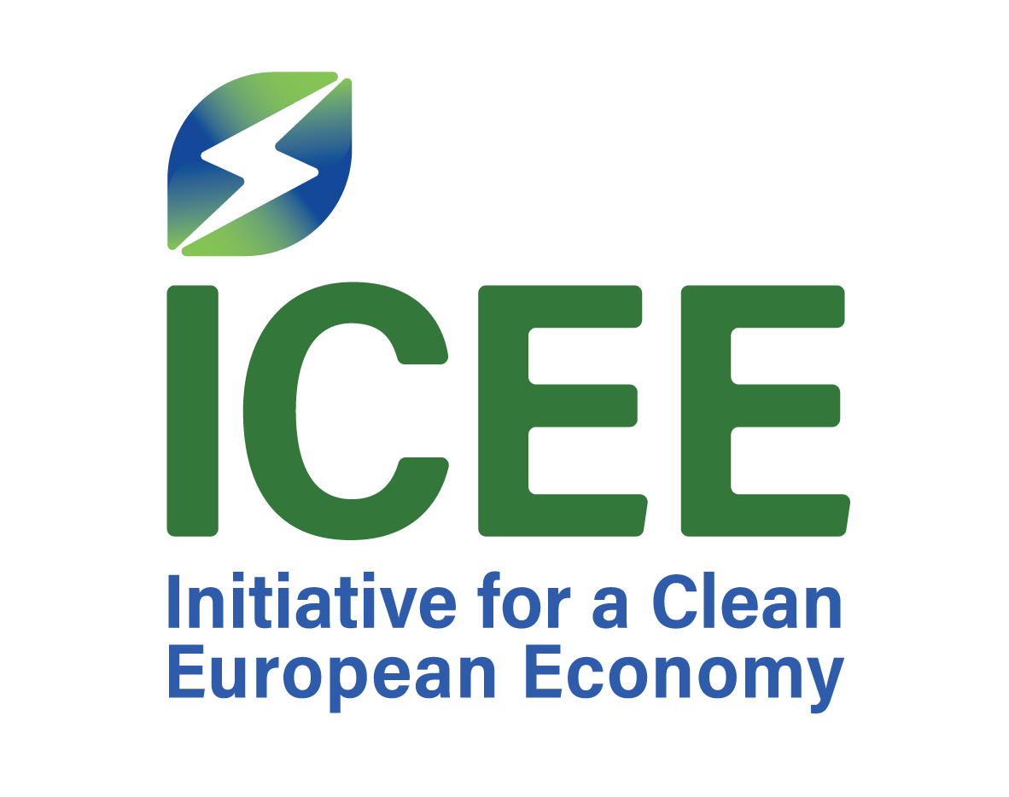

EUROPEAN GREEN TRANSITION FINANCE FORUM – ZAGREB 2026

13 November 2026 – Hotel Esplanade Zagreb

Dear Sir or Madam,
On behalf of the Initiative for a Clean European Economy (ICEE), it is our pleasure to welcome you to the European Green Transition Finance Forum - Zagreb 2026.
The Forum brings together a carefully selected group of senior policymakers, central bank representatives, government officials, researchers and experts from across Europe to discuss one of the defining economic challenges of the coming years: how to finance the green transition while strengthening European competitiveness, industrial resilience and long-term economic growth.
The programme is built around two ICEE-commissioned research projects presented by Prof. Danijel Mlinarić and Prof. Gregor Semieniuk. Each research session will combine a presentation of key findings with a structured exchange involving an invited commentator, followed by a broader discussion with Forum participants. The two sessions will address green-transition financing, investment needs, European industrial value chains, competitiveness and the policy choices shaping the transition across Europe.
Following the conference programme and networking reception, the Forum will conclude with a private dinner. A special address will be delivered during the dinner by Prof. Boris Vujčić, Vice-President of the European Central Bank.
We have deliberately designed the Forum as a closed, invitation-only gathering. Our intention is to create an environment in which participants can speak openly, test ideas, challenge assumptions and exchange perspectives across institutional and national boundaries. To facilitate participation and ensure a seamless experience for our invited guests, ICEE will cover the cost of air travel and accommodation in Zagreb for Forum participants, with the necessary arrangements coordinated directly with each participant.
ICEE was established with the conviction that the transition to a cleaner European economy must be economically credible, financially viable and grounded in a realistic understanding of how businesses, governments and financial institutions respond to change. We hope this Forum contributes to that objective.
Thank you for joining us in Zagreb and for contributing your experience and perspective to the discussion. We look forward to a thoughtful, substantive and constructive exchange.
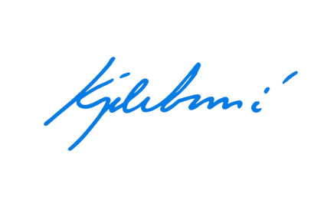
With kind regards,
Andrija Kojaković
President

Initiative for a Clean European Economy (ICEE)

